 |  | Autumn 1 | Autumn 2 | Spring 1 |  | Spring 2 |  |  | Summer 1 |  |  | Summer 2
Reception and Year 1  Wrens | Poetry and non-fiction will be interweaved throughout the year in English lessons, Guided Reading 1:1 reading, home-reading and class texts. Children will also choose from a wide selection of genres and authors in their class libraries.
 | Theme | Supertato | Houses and Homes | Outer Space |  |  | Animal Adventures |  | Jack & The Beanstalk |  | Olympics
 | Class Texts | Supertato  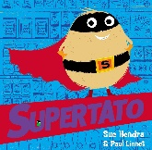 | The Three Little Pigs  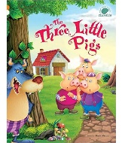 | Whatever Next!  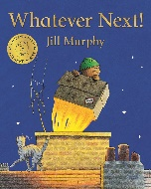 |  | 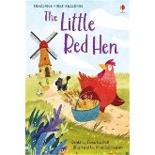  The Little Red Hen |  |  | 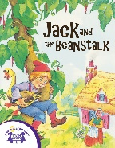  Jack and the Beanstalk |  | 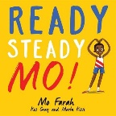  Ready Steady Mo!
 | Suggested Texts  and ‘old favourites’ | Supertato series books  Superworm  Super Daisy  Superhero ABC | Home  By Carson Ellis  The House that Jack built | How to catch a star  Penguinaut  Toys in Space |  | The Lion inside  Giraffes can’t dance  The Tiger who came to tea |  |  | Jasper’s beanstalk  Oliver’s vegetables  How to plant a seed |  | Going for gold
 | EYFS | Writing outcomes - EYFS  Write recognisable letters, most of which are correctly formed – linked to phonics phase  Spell words by identifying sounds in them and representing the sounds with a letter or letters  Write simple phrases and sentences that can be ready by others.  Reading and comprehension outcomes - EYFS  Demonstrate understanding of what has been read to them by retelling stories  and narratives using their own words and recently introduced vocabulary; -Anticipate – where appropriate – key events in stories; -Use and understand recently introduced vocabulary during discussions about  stories, non-fiction, rhymes and poems and during role-play.  Say a sound for each letter in the alphabet and at least 10 digraphs; -Read words consistent with their phonic knowledge by sound-blending; -Read aloud simple sentences and books that are consistent with their phonic  knowledge, including some common exception words.
 | Writing Purpose | To entertain  Descriptive Writing  To inform  Recounts  Wanted Posters | To entertain  Traditional Tales  Innovated stories with repetitive patterns or structure  To inform  Wanted Posters - with a twist | To inform  Instructions  Lists, labels and captions  Safety Information Posters |  | To inform  Fact sheets  Recounts  To entertain and perform  Innovated stories with repetitive patterns or structure (based on Little Red Hen)  Rhyme and Pattern |  |  | To inform  Instructions  Lists, labels, captions  News reports |  |  | To persuade  Adverts  To entertain and perform  Poems on a theme
Robins  Year 1 and 2 | Theme | Traditions |  |  | All in a Dream |  |  | Animal Adventures
 | Class Text | The Deep The Pobble  Dark Wood With  No Toes  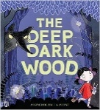  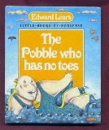  Monty the Penguin  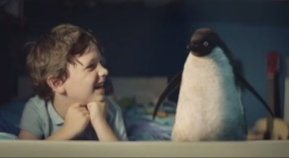 |  |  | Aladdin Beegu  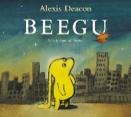  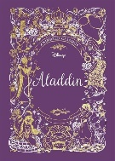 |  |  | The Wind The Variety  in the of Life  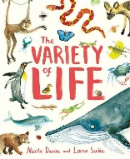  Willows  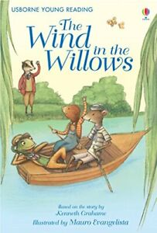  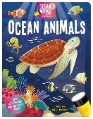  Ocean Animals
 | Suggested Writing Outcomes | Innovated Traditional Tale Story – to entertain  Nonsense Poem - to entertain  A set of instructions for a young child - to inform |  |  | An adventure story unit – to entertain  Postcard and diary entries – to communicate |  |  | Innovated adventure story - to entertain  Animal Riddle - to entertain  Non-Chronological report – to inform
Owls  Year 3 and 4 | Theme | The Abominables | Our Environment |  | Water, Water Everywhere | Myths & Legends |  | Ancient Egypt |  | Money, Money, Money
 | Class Text | The Abominables  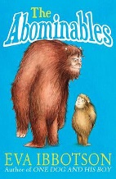 | 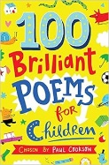  100 Brilliant Poems for Children |  | 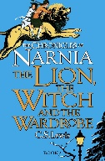  The Lion, The With and the Wardrobe | 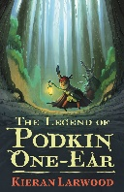  The Legend of Podkin One-Ear |  | 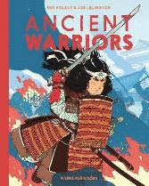  Ancient Warriors |  | 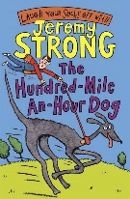  100 Mile an Hour Dog
 | Supporting Texts |  | Snake Glides by Keith Bosley.  The Raindrop by John Travers Moore.  Word Whirls and other Shape Poems by John Foster.  Kenn Nesbitt's Poetry 4 Kids – How to write concrete poetry  Angela's Poems – Shape Poems or Calligram  Young Writers – Shape Poems |  |  |  |  | 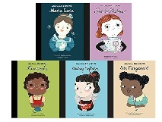
 | Suggested Writing Outcomes | To entertain:  An innovated narrative  Character descriptions  To inform:  Non-chronological reports  Debate/discussion texts | To entertain:  Performing poetry  Writing poetry |  | To entertain:  To inform:  Letters  Diaries | To entertain:  An innovated myth story  To inform:  Diaries |  | To inform:  Biographies  Explanation texts |  | To persuade:  Adverts  To inform:  Explanation
Jays  Year 5 | Theme | This is ME! |  |  | Ancient Greece | Inventors & Inventions |  | Amazon Adventure
 | Class Text | The Nowhere Emporium  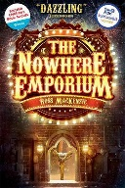 |  |  | 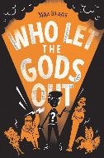  Who let the gods out? | The Portal  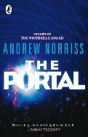 |  | 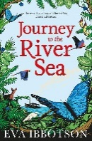  Journey to the River Sea
 | Supporting Texts | Non-fiction selection |  |  | Greek Myths Collection | Hugo Cabaret |  | Kapok Tree
 | Suggested writing outcomes | To entertain:  A short narrative focusing on settings. | To persuade:  Debates/discussions  To inform:  Hybrids |  | To entertain:  An innovated myth | To entertain:  Innovated invention story  To inform:  Instructions |  | To entertain:  Narrative focusing on a different setting  To inform:  Non-chronological report  Leaflets  Explanation texts  To persuade:  Debate/discussion
Eagles  Year 6 | Theme | Survival! | Children of War |  | The Classics |  |  | Viva, Las Vegas!
 | Class Text | Kensuke’s Kingdom  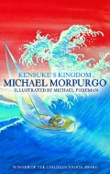 | 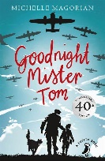  Goodnight, Mr Tom |  | The Highwayman  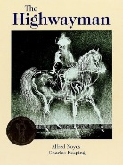 | Macbeth  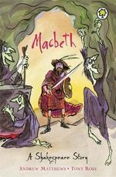 |  | Wonder  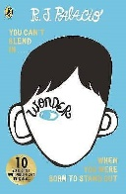
 | Supporting Texts | Robinson Crusoe by Daniel Defoe.  Bear Grylls Mission Survival: Gold of the Gods.  Running Wild by Michael Morpurgo.  Amazon Adventure by Willard Price.  My Side of the Mountain by Jean Craighead George.  Wild Girl Adventures by Helen Skelton | Once by Morris Gleitzman  Anne Frank’s Diary  The Boy in the Striped Pyjamas by John Boyne  Carrie’s War by Nina Bawden  Mt Secret War Diary by Marcia Williams |  | Jabberwocky by Lewis Carrol  The Raven by Edgar Allan Poe  Timothy Winters by Charles Causley.  Chip the glasses and crack the plates, JRR Tolkien | Macbeth by William Shakespeare.  Romeo and Juliet by William Shakespeare.  Shakespeare Stories by Leon Garfield.  Stories from Shakespeare by Usborne. |  | Pig Heart Boy by Malorie Blackman  Cloud Busting by Malorie Blackman  Face by Benjamin Zephaniah
 | Suggested writing outcomes | Narrative based on model text  Writing for a range of purposes including:  To inform (newspapers/letters  Non-chronological reports)  To entertain – short story and setting descriptions and poetry | Novel as a theme  Writing for a range of purposes including:  To persuade (debate/discussion)  To entertain (short story set in the past, character descriptions)  To inform (diaries/letters Non-chronological reports) |  | Narrative Poetry  Writing for a range of purposes including:  To persuade  (debate/discussion)  To entertain  (narrative poem based on a model)  To inform  (newspapers and Non-chronological reports) | Classic Texts  Writing for a range of purposes including:  To entertain  (a narrative in the style of Shakespeare, poetry)  To persuade (discussion/debate) |  | Novel as a Theme  Writing for a range of purposes including:  To persuade  (debate)  To entertain  (poetry)  To inform  (diaries/letters/  Non-chronological report)  Children will independently choose the appropriate writing outcome linked to the audience and purpose to create a hybrid text.

