Personal, Social and Emotional Development & HRSE
See themselves as a valuable individual. Build constructive and respectful relationships. Express their feelings and consider the feelings of others. Show resilience and perseverance in the face of challenge. Identify and moderate their own feelings socially and emotionally

’

Physical Development
GM - Secure fundamental movement skills
- develop coordination and negotiate space through Games
- further develop expression and routine through dance/Zumba
- Use of bikes, trikes and scooters
FM - continued development of mark making skills; secure correct posture, tripod pencil grip, control
continue to develop correct letter formation, orientation, size
- use craft tools correctly and independently scissors, paintbrushes,
- use gardening tools safely and appropriately

R.E.
Easter – the good news of the resurrection
Pentecost; passing on the Good News of Jesus
May, month of Mary, Mother of God

School value for this half term – be honest
Other faiths – Islam; Eid-al-Fitr

WRENS YR
Jack and the Beanstalk
Summer 1 2024

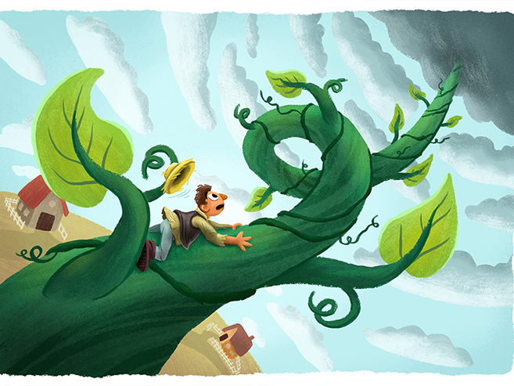
Expressive Arts and Design
- continue to develop mark making skills and use tools to explore line, shape, pattern
- continue to explore colour, shape, texture through a range of art and craft materials
- work to secure correct use and safe use of craft tools independently eg scissors
- demonstrate ability to plan a design and talk about what they are doing and the processes involved
- maximise opportunities to develop narrative skills through small world and imaginative play in relation to topic (Jack’s cottage, plant shop/garden centre)
- learn new songs/rhymes in relation to topic
-

Creating and representing vehicles in 2D and 3D

Construction kits; wheel based, cogs

Communication and Language
- work to secure good listening skills across different situations; in groups, whole class, school
- respond to what they hear by asking and answering questions appropriately and with increased confidence
- Listen to and follow more complex instructions
- confidently engage in conversations with familiar people
- continue to develop, understand and use new vocabulary in context when speaking (ie topic vocab)
- talk in full sentences, using conjunctions as appropriate
- further develop correct use of tenses when speaking

Key text; Jack and the Beanstalk

Supporting texts; Jim and the Beanstalk, Jill and the Beanstalk, Jasper’s Beanstalk

Model text – How to train a train Supporting Texts; Mr Gumpy’s outi
Literacy
- Secure all letters, sounds and HFW at Phase 3, using and applying these when reading and writing
- Introduce adjacent consonants at Phase 4 and be able to segment and blend polysyllabic words when reading and writing & learn Phase 4 HFW
- Enjoy listening to, reading and talking about a range of books, including non-fiction, using new vocabulary in context. Recognise the language of stories
- Read and write simple sentences with increasing independence, using their growing phonic knowledge to help them
- Enjoy writing for different purposes eg labels/captions, recounts, simple stories, instructions
- Ensure writing can be read by self and others, with most letters correctly formed
- Remember to use finger spaces between words and punctuation as appropriate (. ! ?)

Understanding of the World
- describe their immediate environment using knowledge from observation, discussion, stories, non-fiction texts and maps.
- Explore the natural world, making observations about plants and living things
- observe life cycles, including plants and experience and respond to different stages of growth
- Plant seeds and observe how they grow
- Notice the changes in the natural world, including the seasons.

-

Mathematics
- Build and represent numbers beyond 10,
- verbal counting beyond 20
- Explore sharing and grouping, including odd and even groups, doubles and halves
- Manipulate, rotate, compose and decompose shapes

-

