Physical Development
GM - cont to develop fundamental movement skills
(see Lancs PE passport)
FM - Continue to develop correct use of pencils, scissors, cutlery etc. Encourage correct posture, grip and control. Continue to develop letter formation and orientation.
Malleable play; moulding, pinching, kneading, shaping

Personal, Social and Emotional
Development & HRSE
- Growing, changing and life cycles
- keeping safe
- Positive relationships
- My Happy Mind

’

R.E.
Lent; a time of renewal and positive change

Ash Wednesday, Temptation in the desert

- Holy Week and the Easter Tridiuum

School value this half term; Be Generous

School value for this half term – be generous

Communication and Language
- enjoy being part of conversations and discussions and respond with sensible comments, relevant actions and questions
- use talk in different ways to develop thinking, collaborate and plan with others and to express ideas
- learn and use new vocabulary in context
- further develop active listening skills
- listen to and talk about stories and their sequence
- retell stories using T4W
- develop language, vocabulary and narrative skills through storytelling imaginative and small world play
- listen and talk about non-fiction books in relation to topic. Ask and answer questions
- follow more complex instructions

Expressive Arts and Design
- continue to explore colour, shape, texture through art and craft materials
- malleable play; dough; kneading, rolling, pinching
- imaginative play with animal enhancements
- continued use of construction kits; building for a purpose, talking about the process, adapting ideas
- Extend repertoire of songs to include topic songs
- use percussion instruments to copy rhythms
- move in time to music
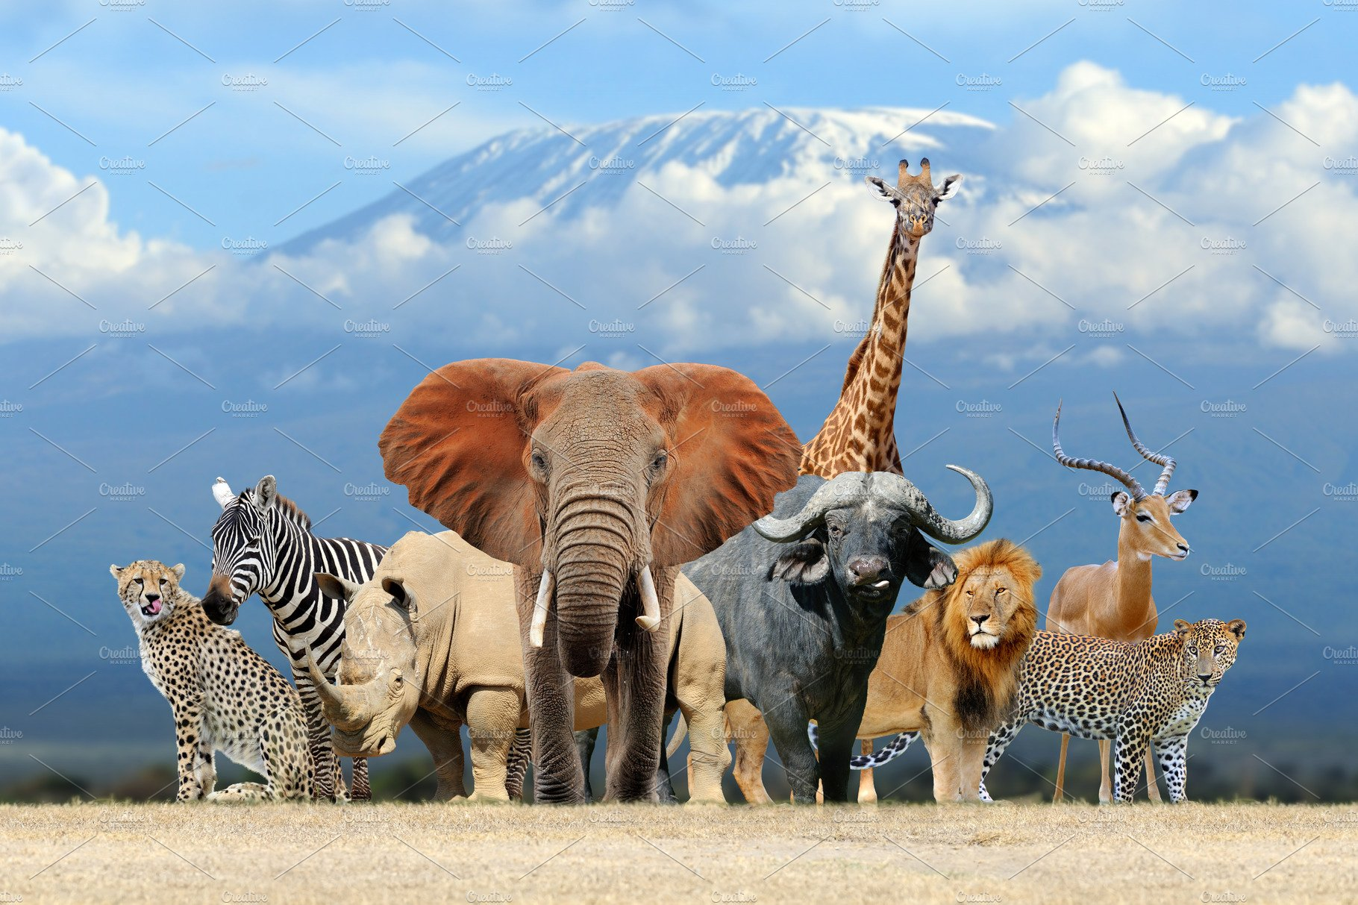
WRENS YR
Animal Adventures
Spring 2 2024

Mathematics

- Numbers to 10, including comparing, representing, subitising
- 1 more/less

- Number bonds to 10

- Length, height and time

- mass and capacity

Understanding of the World
- Develop understanding of how to care for our living world
- Experience and explore what living things need to survive and how to care for them (class stick insects)
- Observe and discuss similarities and differences between living things especially animals.
- Learn that some animals have a special job to do e.g. guide dog
- Know some similarities and differences between the natural world around them and contrasting environments
- Know that different animals live in different parts of the world.

-

Literacy
- continue to learn new digraphs and trigraphs at Phase 3 (intervention where needed). Learn Ph 3 HFW, inc ‘tricky words’.
- blend sounds together to read phase appropriate words
- encourage blending and segmenting sounds to help with reading and spelling.
- Read and write phase appropriate sentences with increasing independence.
- Recognise and use capital letters, full stop, exclamation and question marks, as appropriate.
- Read what you’ve written to check it makes sense!
- encourage correct formation of lower-case letters
(intervention where needed)

Key texts; ‘The Little Red Hen’, ‘Dear Zoo’, ‘Brown Bear, Brown Bear’, ‘‘The Tiger who came to Tea’

